**Tracing the Growth of the Global Community**

**A Population Forecasting Analysis**

**Introduction**

**Overview**

The world’s population is more than three times larger than it was in the mid-twentieth century. The global human population reached 8.0 billion in mid-November 2022 from an estimated 2.5 billion people in 1950, adding 1 billion people since 2010 and 2 billion since 1998. The world’s population is expected to increase by nearly 2 billion persons in the next 30 years, from the current 8 billion to 9.7 billion in 2050 and could peak at nearly 10.4 billion in the mid-2080s. This dramatic growth has been driven largely by increasing numbers of people surviving to reproductive age, the gradual increase in human lifespan, increasing urbanization, and accelerating migration. Major changes in fertility rate have accompanied this growth. These trends will have far-reaching implications for generations to come.

**2.1 Purpose**.

**This dramatic growth has been driven largely by increasing numbers of people surviving to reproductive age, the gradual increase in human lifespan, increasing urbanization, and accelerating migration. Major changes in fertility rate have accompanied this growth. These trends will have far-reaching implications for generations to come.**

**In the solution of any planning problem, the planner either makes an explicit forecast, or makes some implicit assumption about the population for which he is planning. "Population" includes much more than mere numbers of people. The planner must know what kind of people live in his planning area, what types of lives they lead, and would like to lead, how long they will live, and how long they will reside in the particular area; and who will replace them when they move out or die; how many children they will have (and would like to have under different conditions), whether these children will live in the area, and many other factors.**

**Problem defining and designing**

**2.1 Empathy Map**

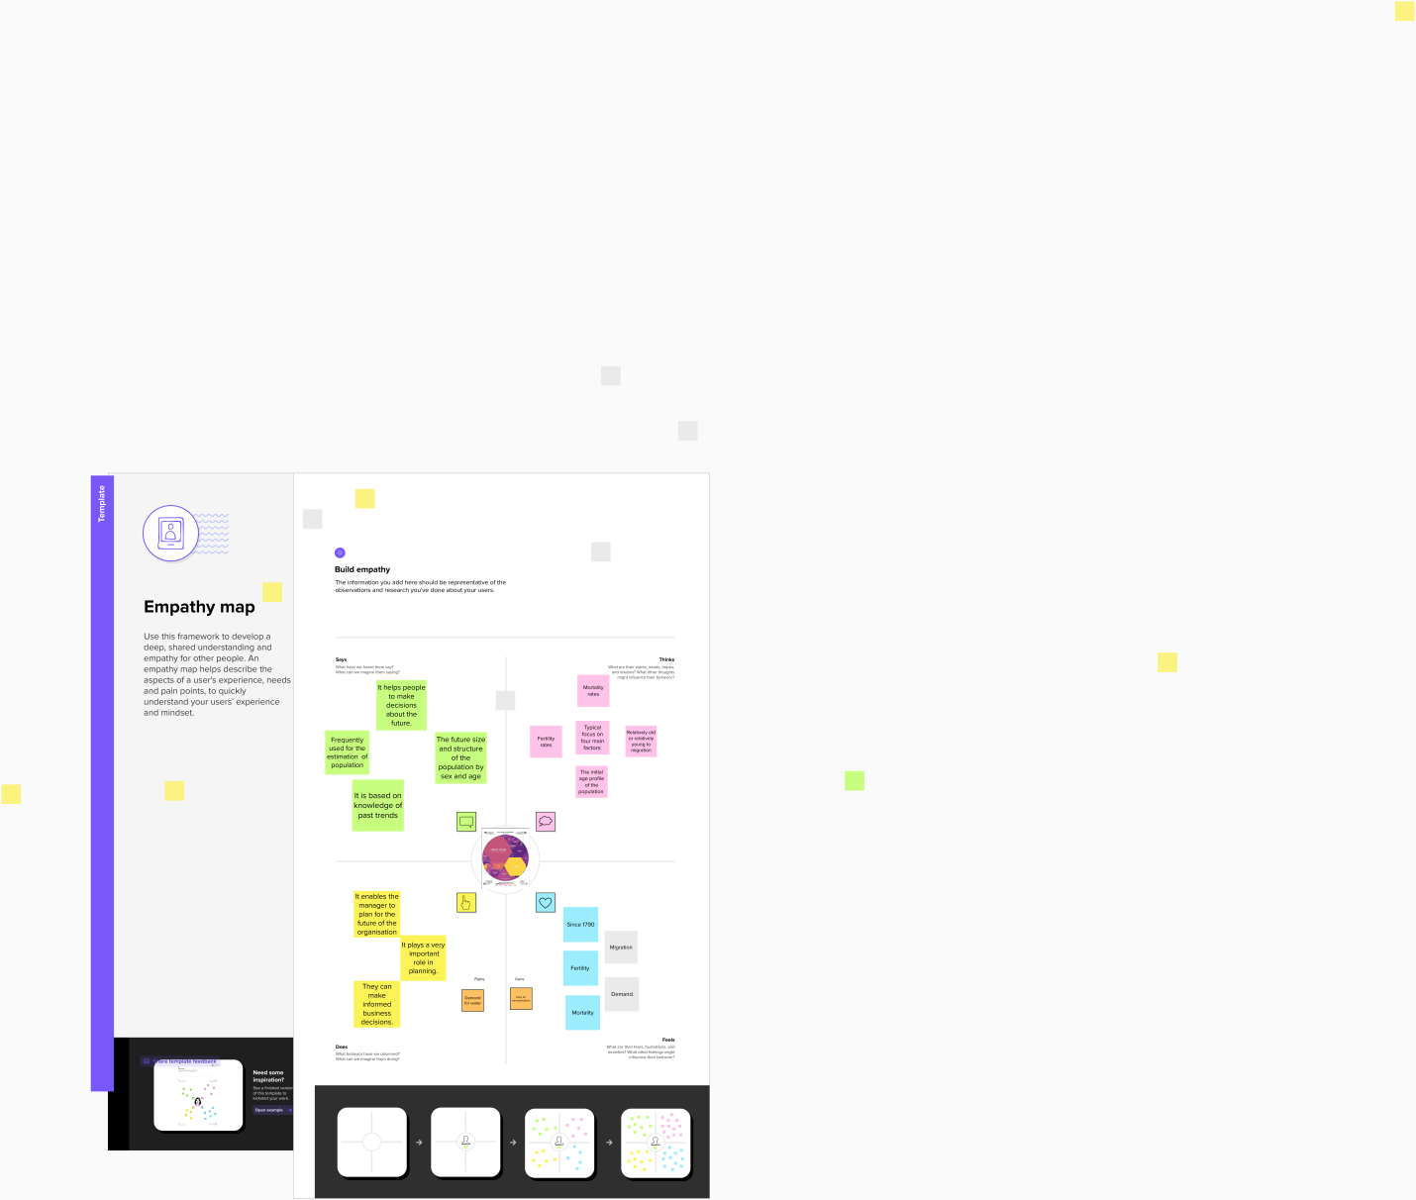

**2.2 Ideation &Brainstorming Map**

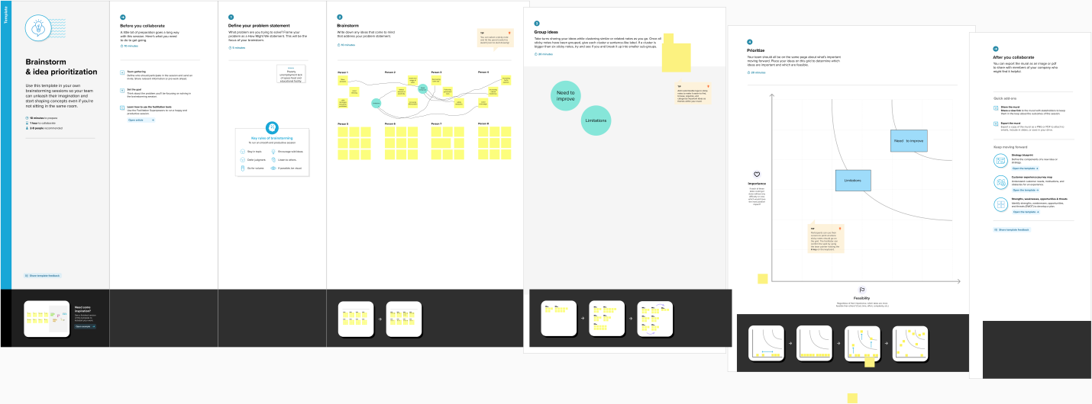

**Result**

**Screenshot of dashboard output**

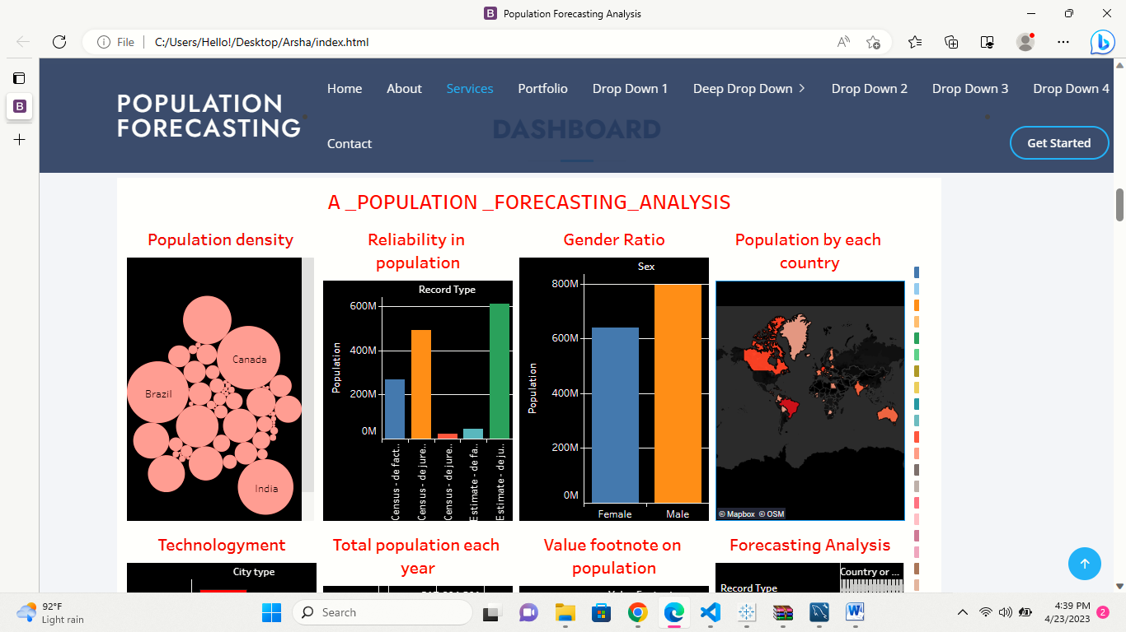

**Screenshot of story output**

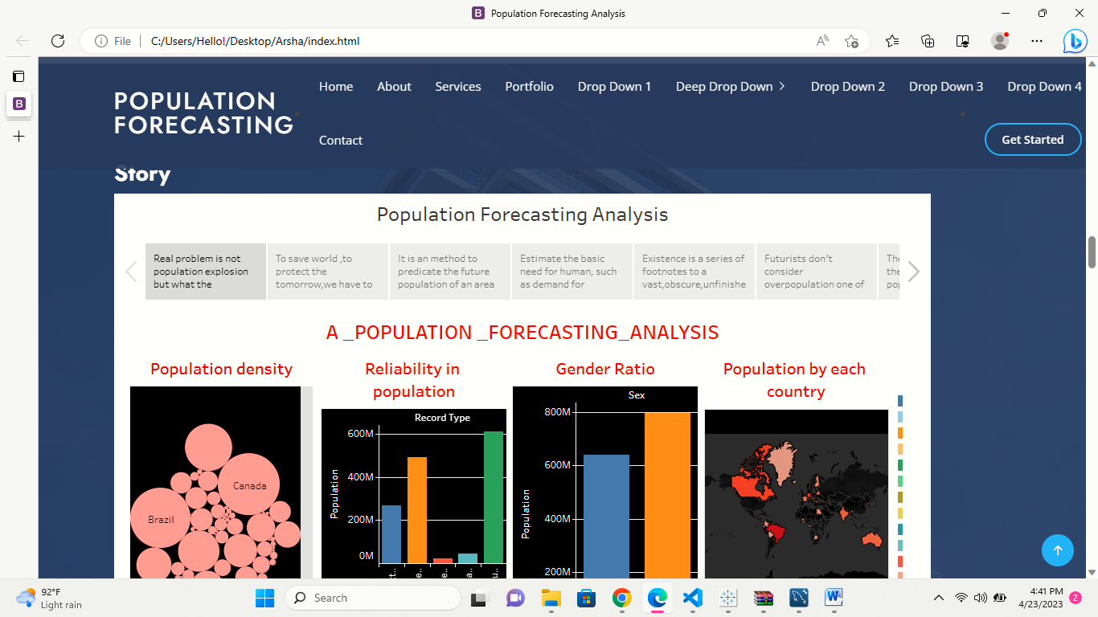

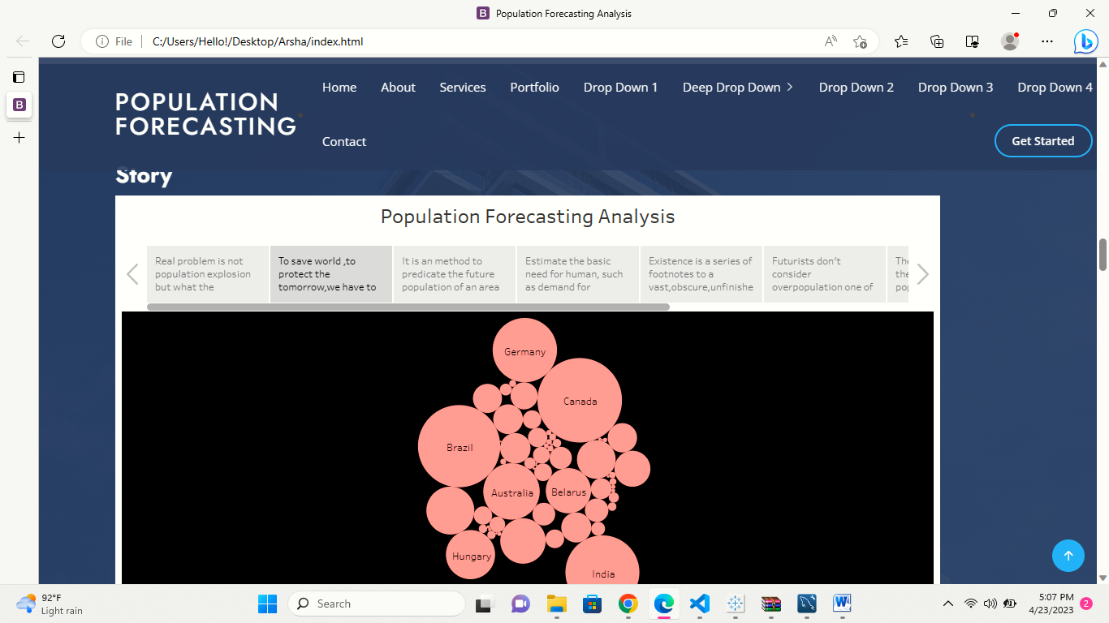

**PROS FOR POPULATION GROWTH**

1. **Increased human capital**
2. **More scope for innovation, invention and creative genius**
3. **Economies of scale from higher population.**
4. **Enables specialization**
5. **Higher population densities more efficient.**
6. **The improved demographic structure of society.**

**CONS OF POPULATION GROWTH**

1. **Increased pressure on natural environment.**
2. **Water shortages.**
3. **Increases pollution.**
4. **Exacerbates global warming**
5. **Congestion.**
6. **Over use of non renewable resources.**

**Applications of forecasting Analysis**

1. **Zoning method for industrial commercial residential an other zones.**
2. **Identify the full range of population not a limited set of illusory certainties.**
3. **Supply the chain management movement and storage of raw material**
4. **The process of making prediction about economic**
5. **Specification of time location and magnitude of a future earthquakes within the stated limits.**
6. **The process of estimating the number of vehicles or people that will specify the transportation facility.**
7. **Telecommunication service problem**
8. **Sales forecasting.**
9. **Weather forecasting**
10. **Flood forecasting**

**FUTURE SCOPE**

**Towards the end of the century, the UN expects the gobal population to reach its peak at around 10.4 billion. After this point the human demographers gobal population to become negative. So the world population starts to fall slowly. It is had to know the population dynamics beyond 2100.**

**CONCLUSION**

**Population explosion is commonly considered as threat and burden on the earth as it not only leads to more demand but also depletion of natural resources. It is biggest problem which affects society, economy of the country and human life.**

**THE GROWTH OF WORLD POPULATION ANALYSIS OF THE PROBLEMS AND RECOMMENDATIONS FOR RESEARCH AND TRAINING.**

 <section id="services" class="services section-bg">

      <div class="container" data-aos="fade-up">

        <div class="section-title">

          <h2>Dashboard</h2>

          <div class='tableauPlaceholder

          ' id='viz1682219560220' style='position: relative'><noscript><a href='#'><img alt='A _POPULATION _FORECASTING_ANALYSIS ' src='https:&#47;&#47;public.tableau.com&#47;static&#47;images&#47;PO&#47;POPULATION_FORECASTING_ANALYSIS&#47;Dashboard1&#47;1_rss.png' style='border: none' /></a></noscript><object class='tableauViz'  style='display:none;'><param name='host_url' value='https%3A%2F%2Fpublic.tableau.com%2F' /> <param name='embed_code_version' value='3' /> <param name='site_root' value='' /><param name='name' value='POPULATION_FORECASTING_ANALYSIS&#47;Dashboard1' /><param name='tabs' value='no' /><param name='toolbar' value='yes' /><param name='static_image' value='https:&#47;&#47;public.tableau.com&#47;static&#47;images&#47;PO&#47;POPULATION_FORECASTING_ANALYSIS&#47;Dashboard1&#47;1.png' /> <param name='animate_transition' value='yes' /><param name='display_static_image' value='yes' /><param name='display_spinner' value='yes' /><param name='display_overlay' value='yes' /><param name='display_count' value='yes' /><param name='language' value='en-US' /></object></div>                <script type='text/javascript'>                    var divElement = document.getElementById('viz1682219560220');                    var vizElement = divElement.getElementsByTagName('object')[0];                    if ( divElement.offsetWidth > 800 ) { vizElement.style.width='1000px';vizElement.style.height='827px';} else if ( divElement.offsetWidth > 500 ) { vizElement.style.width='1000px';vizElement.style.height='827px';} else { vizElement.style.width='100%';vizElement.style.height='2777px';}                     var scriptElement = document.createElement('script');                    scriptElement.src = 'https://public.tableau.com/javascripts/api/viz_v1.js';                    vizElement.parentNode.insertBefore(scriptElement, vizElement);                </script>

        </div>

        </div>

      </div>

    </section><!-- End Services Section -->

    <!-- ======= Cta Section ======= -->

    <section id="cta" class="cta">

      <div class="container" data-aos="zoom-in">

        <div classss="row">

          <div class="col-lg-9 text-center text-lg-start">

            <h3>Story</h3>

            <div class='tableauPlaceholder' id='viz1682220468677' style='position: relative'><noscript><a href='#'><img alt='Population Forecasting Analysis ' src='https:&#47;&#47;public.tableau.com&#47;static&#47;images&#47;PO&#47;POPULATION_FORECASTING_ANALYSISSTORY1&#47;Story1&#47;1_rss.png' style='border: none' /></a></noscript><object class='tableauViz'  style='display:none;'><param name='host_url' value='https%3A%2F%2Fpublic.tableau.com%2F' /> <param name='embed_code_version' value='3' /> <param name='site_root' value='' /><param name='name' value='POPULATION_FORECASTING_ANALYSISSTORY1&#47;Story1' /><param name='tabs' value='no' /><param name='toolbar' value='yes' /><param name='static_image' value='https:&#47;&#47;public.tableau.com&#47;static&#47;images&#47;PO&#47;POPULATION_FORECASTING_ANALYSISSTORY1&#47;Story1&#47;1.png' /> <param name='animate_transition' value='yes' /><param name='display_static_image' value='yes' /><param name='display_spinner' value='yes' /><param name='display_overlay' value='yes' /><param name='display_count' value='yes' /><param name='language' value='en-US' /></object></div>                <script type='text/javascript'>                    var divElement = document.getElementById('viz1682220468677');                    var vizElement = divElement.getElementsByTagName('object')[0];                    vizElement.style.width='1016px';vizElement.style.height='991px';                    var scriptElement = document.createElement('script');                    scriptElement.src = 'https://public.tableau.com/javascripts/api/viz_v1.js';                    vizElement.parentNode.insertBefore(scriptElement, vizElement);                </script>

         </div>

          </div>

        </div>

    </section><!-- End Cta Section -->

    <!-- ======= Portfolio Section ======= -->

    <section id="portfolio" class="portfolio">

      <div class="container" data-aos="fade-up">

        <div class="section-title">

          <h2>Portfolio</h2>

          <p>Magnam dolores commodi suscipit. Necessitatibus eius consequatur ex aliquid fuga eum quidem. Sit sint consectetur velit. Quisquam quos quisquam cupiditate. Et nemo qui impedit suscipit alias ea. Quia fugiat sit in iste officiis commodi quidem hic quas.</p>

        </div>

        <ul id="portfolio-flters" class="d-flex justify-content-center" data-aos="fade-up" data-aos-delay="100">

          <li data-filter="*" class="filter-active">All</li>

          <li data-filter=".filter-app">App</li>

          <li data-filter=".filter-card">Card</li>

          <li data-filter=".filter-web">Web</li>

        </ul>

        <div class="row portfolio-container" data-aos="fade-up" data-aos-delay="200">

          <div class="col-lg-4 col-md-6 portfolio-item filter-app">

            <div class="portfolio-img"><img src="assets/img/portfolio/portfolio-1.jpg" class="img-fluid" alt=""></div>

            <div class="portfolio-info">

              <h4>App 1</h4>

              <p>App</p>

              <a href="assets/img/portfolio/portfolio-1.jpg" data-gallery="portfolioGallery" class="portfolio-lightbox preview-link" title="App 1"><i class="bx bx-plus"></i></a>

              <a href="portfolio-details.html" class="details-link" title="More Details"><i class="bx bx-link"></i></a>

            </div>

          </div>

          <div class="col-lg-4 col-md-6 portfolio-item filter-web">

            <div class="portfolio-img"><img src="assets/img/portfolio/portfolio-2.jpg" class="img-fluid" alt=""></div>

            <div class="portfolio-info">

              <h4>Web 3</h4>

              <p>Web</p>

              <a href="assets/img/portfolio/portfolio-2.jpg" data-gallery="portfolioGallery" class="portfolio-lightbox preview-link" title="Web 3"><i class="bx bx-plus"></i></a>

              <a href="portfolio-details.html" class="details-link" title="More Details"><i class="bx bx-link"></i></a>

            </div>

          </div>

          <div class="col-lg-4 col-md-6 portfolio-item filter-app">

            <div class="portfolio-img"><img src="assets/img/portfolio/portfolio-3.jpg" class="img-fluid" alt=""></div>

            <div class="portfolio-info">

              <h4>App 2</h4>

              <p>App</p>

              <a href="assets/img/portfolio/portfolio-3.jpg" data-gallery="portfolioGallery" class="portfolio-lightbox preview-link" title="App 2"><i class="bx bx-plus"></i></a>

              <a href="portfolio-details.html" class="details-link" title="More Details"><i class="bx bx-link"></i></a>

            </div>

          </div>

          <div class="col-lg-4 col-md-6 portfolio-item filter-card">

            <div class="portfolio-img"><img src="assets/img/portfolio/portfolio-4.jpg" class="img-fluid" alt=""></div>

            <div class="portfolio-info">

              <h4>Card 2</h4>

              <p>Card</p>

              <a href="assets/img/portfolio/portfolio-4.jpg" data-gallery="portfolioGallery" class="portfolio-lightbox preview-link" title="Card 2"><i class="bx bx-plus"></i></a>

              <a href="portfolio-details.html" class="details-link" title="More Details"><i class="bx bx-link"></i></a>

            </div>

          </div>

          <div class="col-lg-4 col-md-6 portfolio-item filter-web">

            <div class="portfolio-img"><img src="assets/img/portfolio/portfolio-5.jpg" class="img-fluid" alt=""></div>

            <div class="portfolio-info">

              <h4>Web 2</h4>

              <p>Web</p>

              <a href="assets/img/portfolio/portfolio-5.jpg" data-gallery="portfolioGallery" class="portfolio-lightbox preview-link" title="Web 2"><i class="bx bx-plus"></i></a>

              <a href="portfolio-details.html" class="details-link" title="More Details"><i class="bx bx-link"></i></a>

            </div>

          </div>

          <div class="col-lg-4 col-md-6 portfolio-item filter-app">

            <div class="portfolio-img"><img src="assets/img/portfolio/portfolio-6.jpg" class="img-fluid" alt=""></div>

            <div class="portfolio-info">

              <h4>App 3</h4>

              <p>App</p>

              <a href="assets/img/portfolio/portfolio-6.jpg" data-gallery="portfolioGallery" class="portfolio-lightbox preview-link" title="App 3"><i class="bx bx-plus"></i></a>

              <a href="portfolio-details.html" class="details-link" title="More Details"><i class="bx bx-link"></i></a>

            </div>